# NEED of GATEWAY

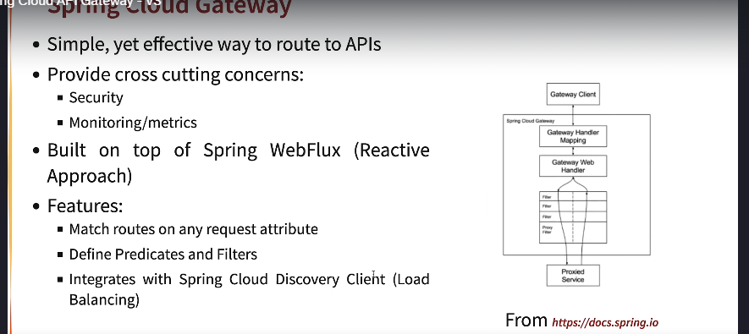

# Ports standardization:

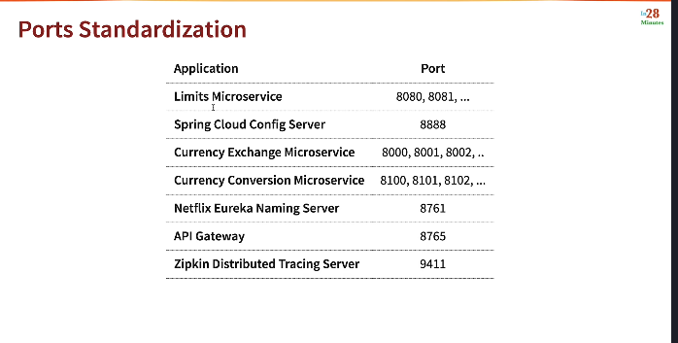

# Setting up API gateway throughout CURRENCY CONVERSION APPLICATION

## Step 1

## Set up api gateway project

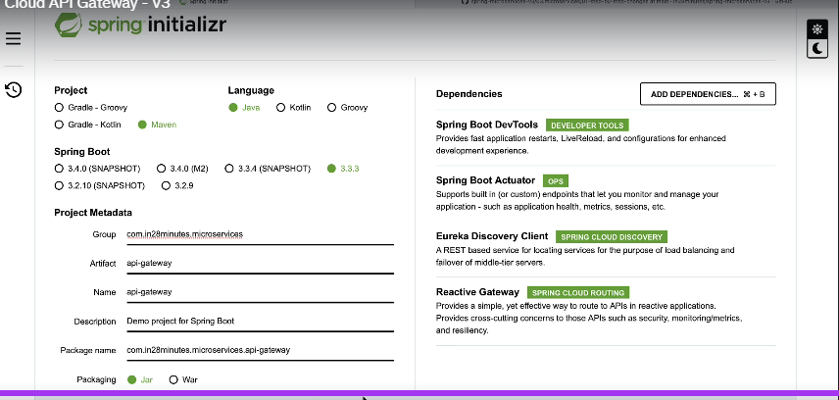

## Enabling Discovery Locator with Eureka for Spring Cloud Gateway

[**http://localhost:8765/CURRENCY-EXCHANGE-SERVICE/currency-exchange/from/USD/to/INR**](http://localhost:8765/CURRENCY-EXCHANGE-SERVICE/currency-exchange/from/USD/to/INR)

**to enable the api call through api gateway and instance name of naming server**

**added this properties in api gateway properties file**

spring.cloud.gateway.discovery.locator.enabled=true

<http://localhost:8765/CURRENCY-EXCHANGE-SERVICE/currency-exchange/from/USD/to/INR>

## to convert the service instance name capital in the url add below property in apigateway properties :

spring.cloud.gateway.discovery.locator.lowerCaseServiceId=true

<http://localhost:8765/currency-exchange-service/currency-exchange/from/USD/to/INR>

## Below is the call to currency conversion from apigateway->namingserver->api

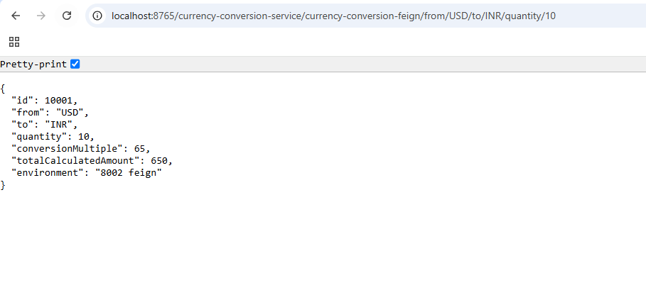

## Old and new urls

### Currency Exchange Service

http://localhost:8001/currency-exchange/from/USD/to/INR

http://localhost:8002/currency-exchange/from/USD/to/INR

### Currency Conversion Service

http://localhost:8100/currency-conversion/from/USD/to/INR/quantity/10

### Eureka Naming Server

http://localhost:8761

### API GATEWAY

http://localhost:8765

### all services endpoint with api gateway

http://localhost:8765/CURRENCY-EXCHANGE-SERVICE/currency-exchange/from/USD/to/INR

http://localhost:8765/CURRENCY-CONVERSION-SERVICE/currency-conversion/from/USD/to/INR/quantity/10

### lowercase

http://localhost:8765/currency-exchange-service/currency-exchange/from/USD/to/INR